ComplyVerse AI for Healthcare & Life Sciences

Governance. Risk. Compliance. Unified by Intelligence.

The Healthcare GRC Challenge
Healthcare organizations operate at the intersection of patient safety, data privacy, and regulatory compliance. A multi-facility health system simultaneously manages obligations across HIPAA (Privacy Rule, Security Rule, Breach Notification Rule), JCI (Joint Commission International) accreditation requirements, FDA regulations for life sciences, state privacy laws, and CMS Conditions of Participation.
The challenge is compounded by the healthcare IT environment: electronic health records, clinical devices (IoT/IoMT), telehealth platforms, imaging systems, patient portals, and extensive third-party vendor ecosystems — all creating a broad attack surface that must be governed, monitored, and documented.

Platform Overview
ComplyVerse AI is an enterprise-grade, AI-native GRC platform that unifies audit management, compliance tracking, enterprise risk management, vulnerability management, IT asset governance, and evidence management into a single, multi-tenant platform.
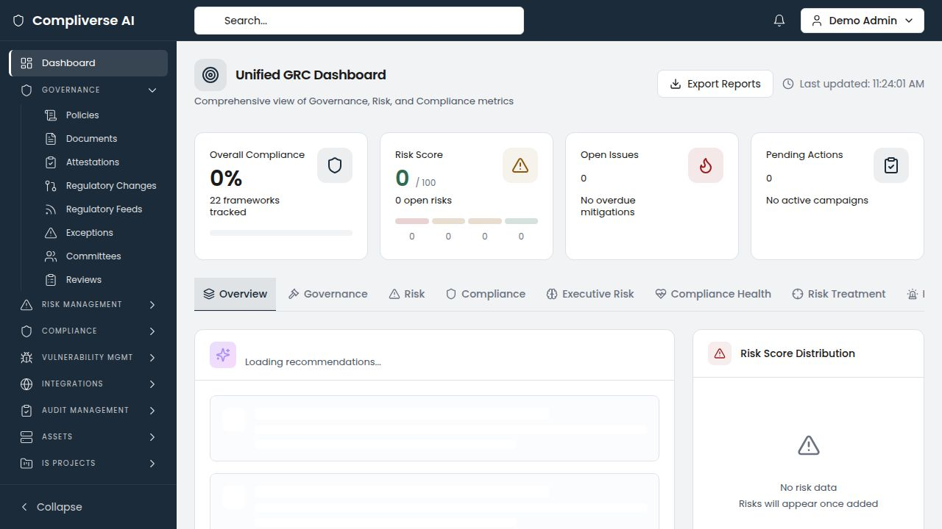

Healthcare-Specific Capabilities

HIPAA-JCI Unified Control Mapping
Upload HIPAA safeguards and JCI accreditation standards. ComplyVerse AI's AI engine automatically identifies overlapping requirements across both frameworks, creating unified control groups. One evidence artifact satisfies both HIPAA and JCI requirements simultaneously, dramatically reducing the burden of dual-compliance programs.
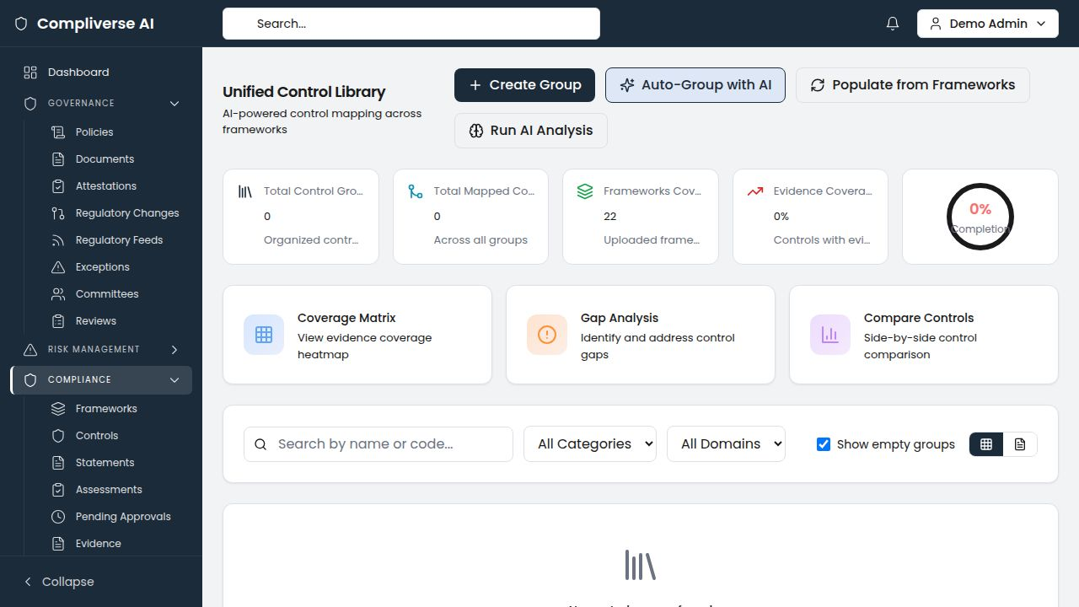
Healthcare Impact: Organizations managing both HIPAA and JCI typically identify 200+ cross-framework control relationships automatically, eliminating duplicate evidence collection and reducing certification preparation by 60–70%.

Evidence Vault for Continuous Accreditation Readiness
Centralize all compliance evidence — access reviews, security configurations, training records, incident response documentation, risk assessments, and policy acknowledgments — in a single vault with version control and approval workflows. When the JCI surveyor or HIPAA auditor arrives, evidence is organized, current, and traceable to specific controls.
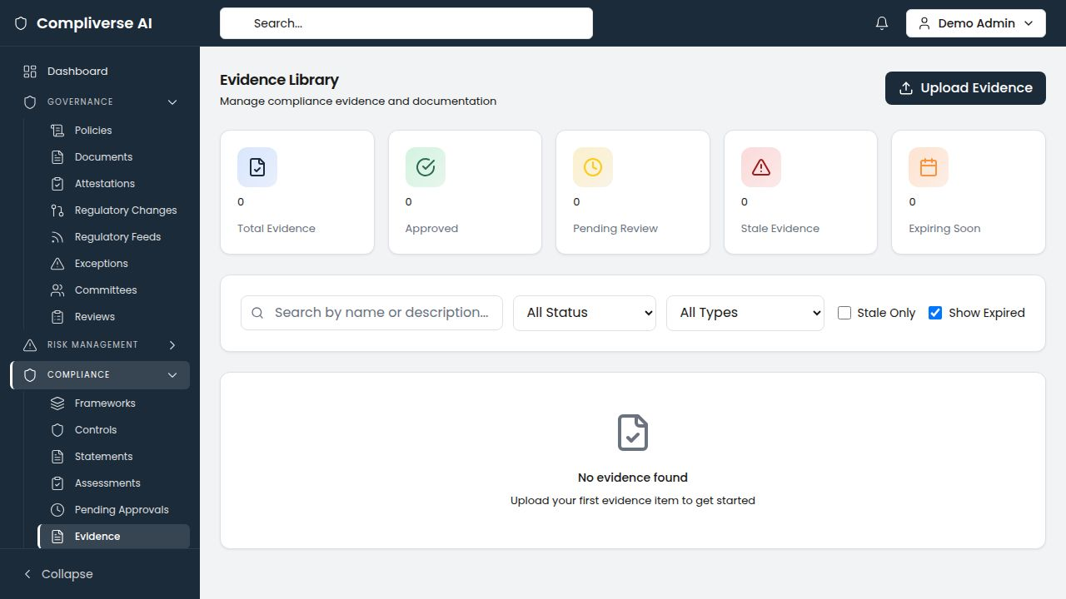
Healthcare Impact: Evidence retrieval time drops from 2–4 hours per request to under 5 minutes. Continuous readiness replaces seasonal scrambles.

Clinical IT Asset Governance
Manage the full healthcare IT asset inventory — from EHR systems and clinical devices to cloud services and third-party vendors. CIA triad ratings are critical in healthcare where patient data confidentiality and system availability directly impact care delivery.
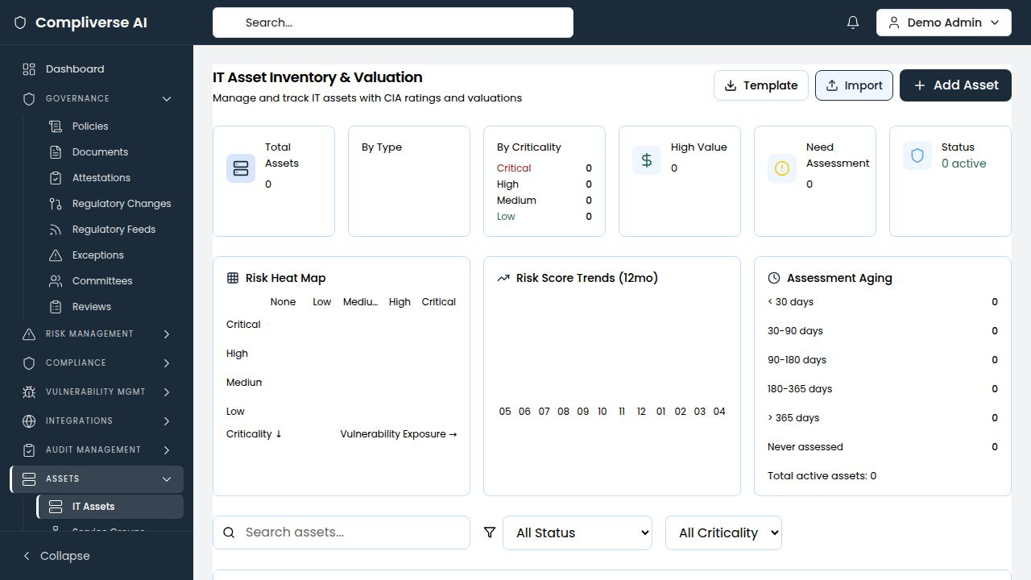
Healthcare Impact: Assets with current risk assessments increase from 30–40% to 85%+. Assessment aging analysis identifies which clinical systems haven't been reviewed recently.

Vulnerability Management with Compensating Controls
Track vulnerabilities across the healthcare IT environment with SLA-based remediation timelines. For medical devices and legacy clinical systems where patching is not immediately possible, document compensating controls and risk acceptance decisions — all linked to the relevant HIPAA safeguards and JCI requirements.
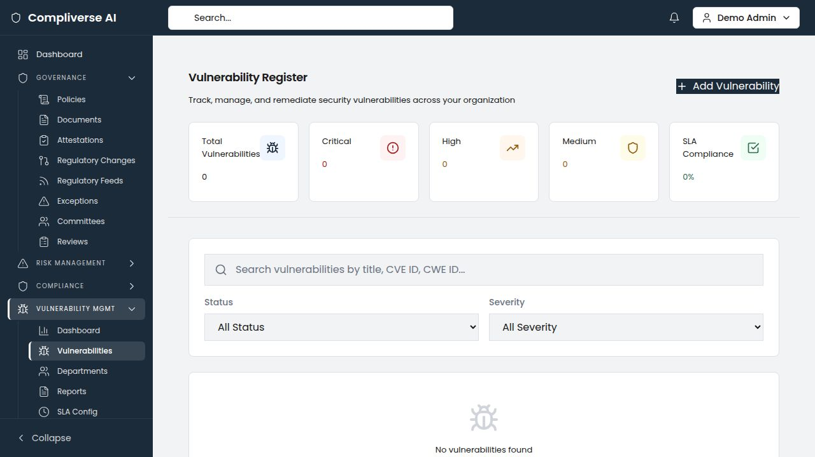

Department-Level Compliance Coordination
Healthcare compliance requires coordination across clinical departments, IT, human resources, facilities, legal, and administration. ComplyVerse AI's role-based access and department-level assignment ensure the right people see the right obligations and evidence requirements.

Audit Management for Healthcare Internal Audit
Full audit lifecycle management for healthcare-specific engagements: HIPAA security risk assessments, clinical department reviews, IT general controls testing, and vendor management audits. AI-powered prior-audit cross-referencing identifies recurring compliance gaps that require systemic remediation.
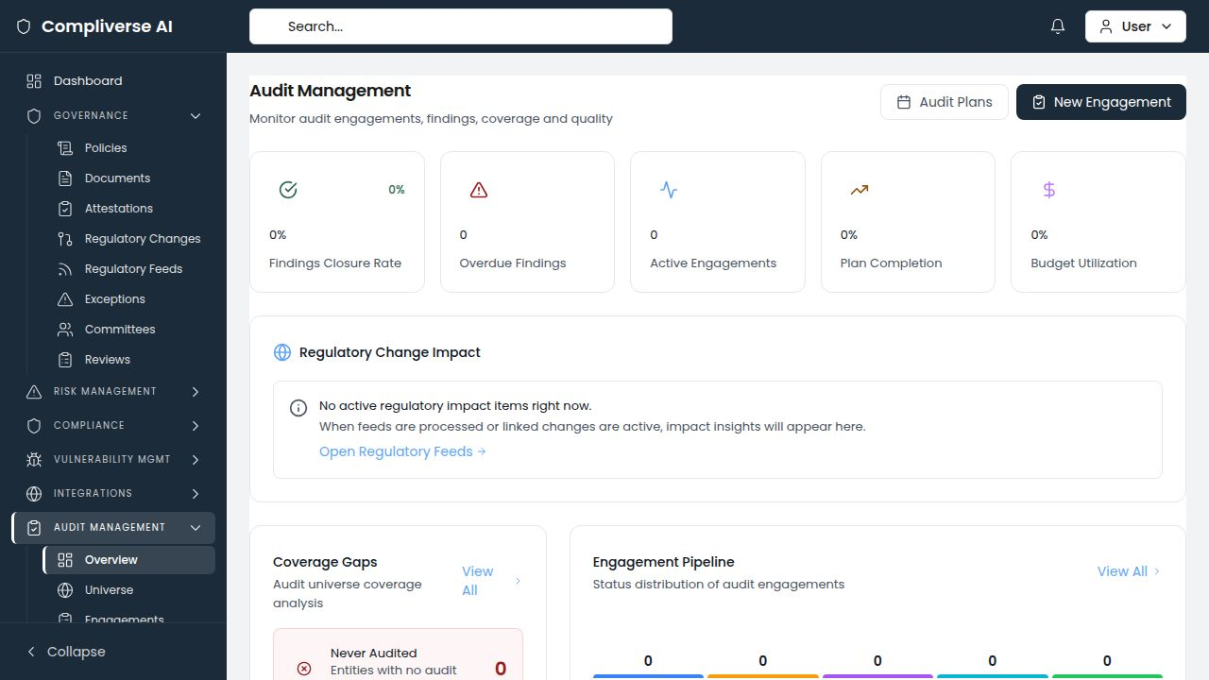

Enterprise Risk Management
Interactive risk heat maps covering clinical, operational, IT, and regulatory risk categories. Department-level risk ownership ensures clinical leaders, IT directors, and compliance officers are accountable for their risk domains.
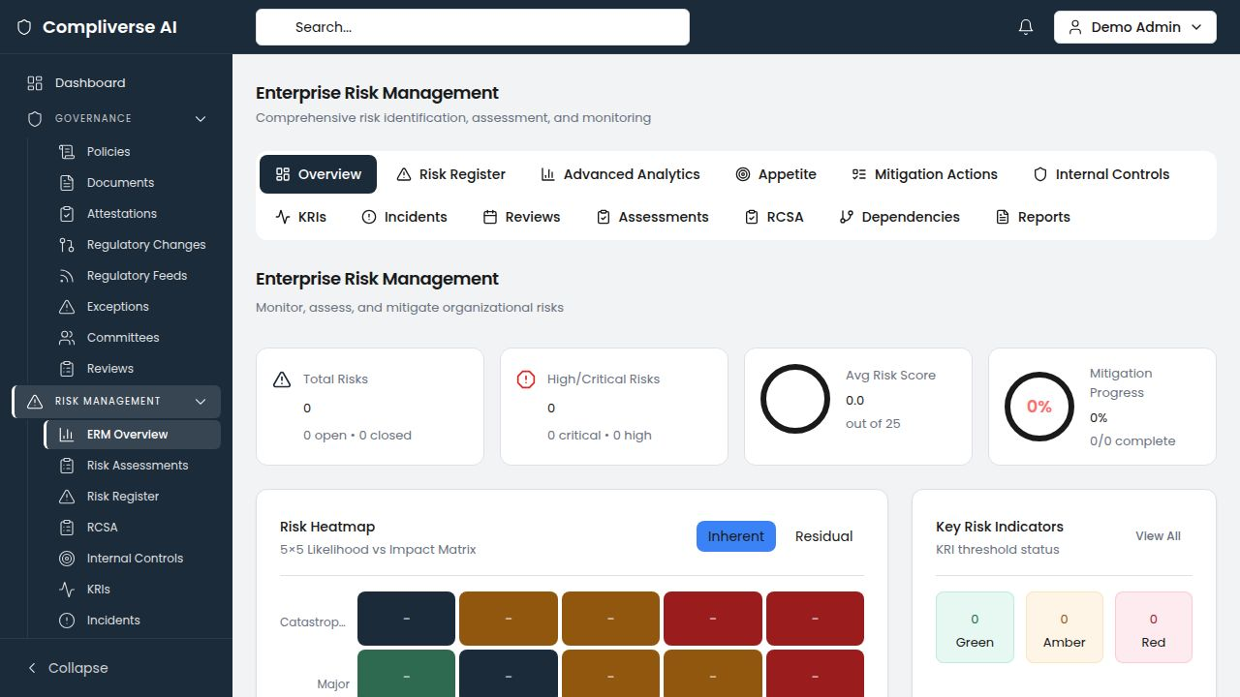

Healthcare Compliance Frameworks Supported
Framework | Coverage
HIPAA Privacy Rule | Full safeguard tracking with evidence mapping
HIPAA Security Rule | Administrative, physical, and technical safeguards
HIPAA Breach Notification Rule | Incident documentation and notification tracking
JCI Accreditation Standards | Full standard upload and control mapping
FDA 21 CFR Part 11 | Electronic records and signatures (life sciences)
HITECH Act | Enforcement and breach notification
CMS Conditions of Participation | Medicare/Medicaid compliance
HITRUST CSF | Full framework with HIPAA cross-mapping
State Privacy Laws | Upload and map state-specific requirements
ISO 27001 | Information security management overlay

Key Metrics for Healthcare
Metric | Impact
JCI/HIPAA evidence preparation time | 60–70% reduction
Controls with evidence coverage | From 60–70% to 90%+
IT assets with current assessments | From 30–40% to 85%+
Evidence retrieval time (per request) | From 2–4 hours to under 5 minutes
Cross-framework evidence duplication | Eliminated (unified mapping)

Getting Started
- Discovery Call — Assess your current compliance landscape across HIPAA, JCI, and other frameworks
- Framework Upload — Import HIPAA safeguards, JCI standards, and applicable regulations
- Asset Import — Bulk-import IT asset inventory with CIA ratings via CSV
- Evidence Migration — Migrate existing evidence library into the unified vault
- AI Analysis — Run cross-framework mapping and identify coverage gaps
Typical time to first value: 3–5 weeks
Schedule Your Demo: [demo-link]
Contact: info@[company-domain].com
ComplyVerse AI — Governance. Risk. Compliance. Unified by Intelligence.

